**JIT Project Blueprint**

***Chengdu FAE – P84***

***(Song Jifeng)***

Blueprint version control:

|  |  |  |  |  |
| --- | --- | --- | --- | --- |
| Version | Date | Description of changes | Status | Approved by |
| 01 | 06/07/2016 | Creation | Draft | *Approver name1*  *Approver name2*  *Approver name3* |

**Table of Contents**

1 3

2 Introduction 3

3 Functional Scope 3

4 Field of application (activities covered) 3

5 Specifications 3

5.1 Introduction 3

5.2 Data flow description 4

5.3 ERP technical data integration 4

5.3.1 Parts master 4

5.3.2 Features to be documented in ERP for JIT system 5

5.4 EDI message description 5

5.4.1 File description 5

5.4.2 File integration 6

6 Production 6

6.1 Process description 6

6.2 Production launching 6

7 Shipping (In Anting warehouse) 6

7.1 Matching: 7

7.2 Container loading 7

7.3 Truck loading 7

8 Labels & printouts 7

8.1 Container labels 7

8.2 Delivery Note 7

9 Events management 7

10 Hardware architecture 7

11 Project schedule 8

# 

# Introduction

Description of the functions necessary for P84 Chengdu FAE to build and delivery in sequence the parts requested by PSA Chengdu for the P84 vehicle.

IJCORE will be used to support these functions.

Faurecia will have to sequence parts from PSA for current production on P84 assembly line.

# Functional Scope

*- Integrate the Master data received from the ERP SAP (FCS)*

*- Send events to ERP (Stock management) (ODL, EXP)*

*- Integrate the customer EDI message*

*- Ensure the conformity functions during the delivery process*

# Field of application (activities covered)

GIS project team will be responsible for:

* *Implementation of the Software (including developments & parameterization)*
* *Tests*
* *Training*
* *Documentation*
* *Assistance to the start up*
* *Handover to Support Chain*

# Specifications

## Introduction

Faurecia Chengdu FAE will produce the Tailgate, Bumper and deliver them in sequence for the P84 project.

The production will be done in sequence from a PSA message (6000) received through EDI.

The production will be delivered in sequence from a PSA message (6000) received through EDI.

## Data flow description

*Insert a scheme clearly showing the data flows.*

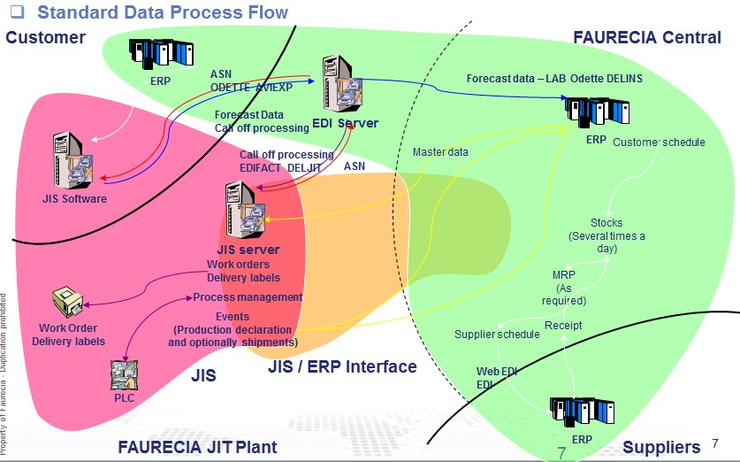

## ERP technical data integration

The ERP “SAP” (FCS) is implemented in Faurecia Chengdu FAE plant.

TWO type’s files will be transmitted:

* Part
* Features

### Parts master

*It will be the standard FCS part file*

### Features to be documented in ERP for JIT system

*Describe how features should be maintained in ERP. Example:*

**PARTPROJECT/PARTMODULE/ PARTFAMILY**

## EDI message description

We get one file from PSA (EFI system) for Container information when the car is going in customer assembly line.

* 1 file for 1 part
* Each 2-3 min (需要确认)

Local EDI will receive container file and convert to part information send to IJCORE with XML format

.

### File description

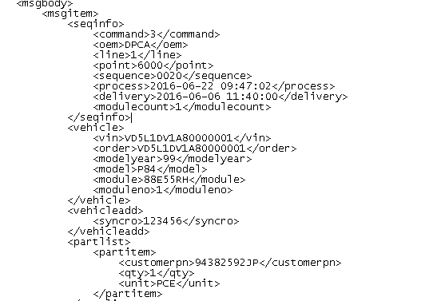

DPCA will send final part numbers for each car -1 file for 1 part

**Sequence control**

To check that we don’t miss one sequence is done with the TAG (<sequence>6221</sequence>) “6221-prodcution sequence”

Counter limit is : 0001-9999

### File integration

EDI system will get the TXT file from DPCA

The TXT file is generated each 2-3 min and will contain all cars that goes to customer assembly line.

EDI after converted will send the XML file (after converted) to the right folder in IJCore server.

# Production

## Process description

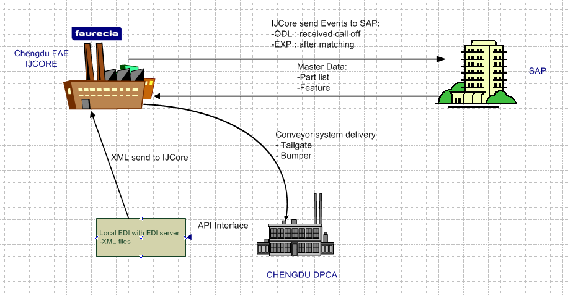

## Production launching

Production Line control system will receive EDI XML files and launch all parts production.

Production Line control system will control Production order, kitting box, and with visual Production info display on Line Screen.

**Customer degraded mode communication (EDI communication)**

In case communication is broken between Faurecia plant and DPCA plant, DPCA will call Faurecia, and faurecia planed production and Delivery by manual.

# Shipping

After sequence produced in plant, the Parts will move to TPA, Operator will have to look for the right parts to pick and set them in the right sequence

## Matching:

## Calloff delivery solution

## After received call off file, the container label will be printed out.

One container for Tailgate

One container for Front & Rear Bumper

Bumper Container:

Step1, Scan Container type,

Step2, Scan production label .

TG Container:

Step1, Scan Container type,

Step2, Scan production label .

## Forecast Solution TBD

TG container:

TPA: from A1 to A60

BUFFER: from B1 to B30

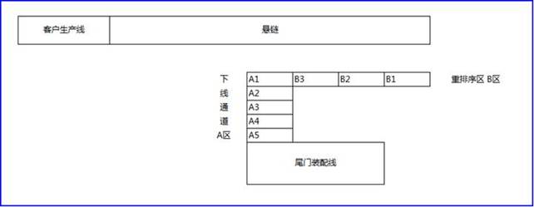

Step1: scan Container type

Step2: scan position, search part in B area (from B1 to B30), if matching pop up message ask operator pick up from B area and scan production label. If not found, then search in A area (always start from A1), if find it, pick up from A area. If not then move this part from A area to B area, put it in minimum empty position, then back to A area continue matching next A area parts. Until it’s matching with requirement.

Step 3: repeat step2 until container finished.

## Container loading

All parts are loading on 2 kinds of container

Container type 1: front & Rear Bumper quantity: 4- 2 Front Bumper, 2 Rear Bumper.

Container type 2: Tailgate, quantity: 6

## Truck loading

No Truck. Delivery by conveyor.

# Labels & printouts

## Container labels

No Container Label

## Delivery Note

No Delivery Note

# Events management

The 2 events to FCS will be used:

ODL,and EXP

Customer order

ODL: **when order is launched in production**

EXP: **When the part scanned at TPA**

# Hardware architecture

*Describe the hardware architecture*

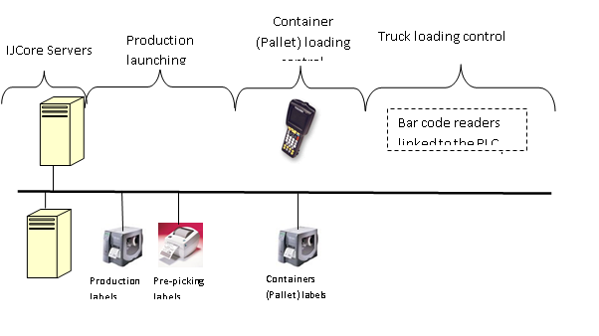

# Project schedule

*Describe the main milestones / deadlines of the project*

|  |  |
| --- | --- |
| ***Milestone (deliverable)*** | ***Deadline*** |
| Specifications validation | W27/2016 |
| **JIT EDI Spec & Development** | **W26/2016** |
| Production server installation for JIT integration | W29/2016 |
| Ijcore configuration | W27/2016 |
| Install EDI server, Printers, PDA, power, network | W22/2016 |
| Key user training  and system integration test and go-live | W33/2016 |

# Project Risk

Because of development new function for Tail Gate Delivery Matching, will impact JIT go live.